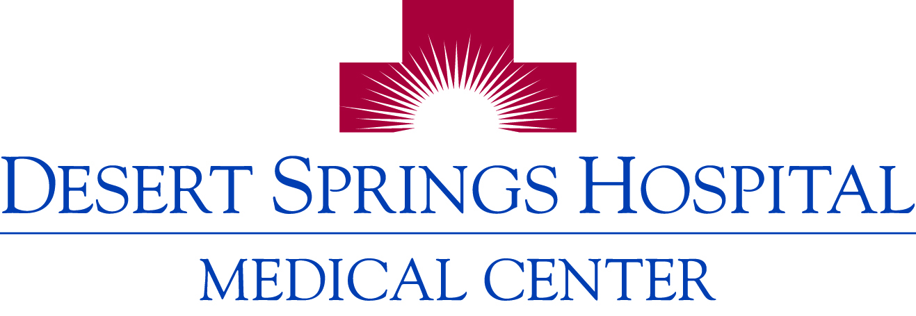
Important Phone Numbers for Physicians

Direct Inpatient Admissions: 591-0320 (24-7)
Speak directly to our House Supervisor, 24-7 to direct admit your patient.
ACCESS
Gero-Psychiatric Admissions: 894-5508
Call to admit your patients 55 and older into our geropsych unit.
Acute Rehabilitation Admissions: 369-7676
Call to admit your patient into our rehab services.

Outpatient Diagnostic Imaging Services: 369-7777 (M-F, 8am-4:30pm)
SCHEDULING
Schedule for imaging services including Interventional Radiology/Angiography, X-ray/Fluoroscopy, Nuclear Medicine (Stress Testing), MRI, Ultrasound, CT Scan.
Cardiology/Cath Lab: 369-7976 (M-F, 6:30am-5pm)
Schedule for interventional cardiology procedures including pacemaker implants, angioplasty, and cardio version.
GI/Endoscopy Lab: 369-7668 (M-F, 7am-5pm)
Schedule for Endoscopy procedures including colonoscopy, bronchoscope, ERCP and Peg tubes.
Surgery/OR Scheduling: 369-7954 (M-F, 8am-5pm)
Pre-Access Center: 369-7710 (M-F, 8-5:30pm) Patient Pre-Registration

Cerner Physician Hotline: 369-7788 (24-7)
ADMINISTRATIVE
Medical Records: 369-7705 (M-F, 8am-5pm)
Credentialing Verification Organization (CVO): 388-4733 (Fax) 889-0742
For application and privileging questions. (M-F, 8am-4pm)
Medical Staff Office: 369-7613 (Fax) 369-7580 (M-F, 7am-3:30pm)
For ER call scheduling, medical staff meetings, privileges, and medical staff issues.
Direct Doctor’s Plus: 388-4888 (M-F, 8am-5pm)
Free physician referrals for patients. Currently, only physicians on medical staff can be listed on the service.
Administration: 369-7612 (M-F, 8am-5pm)
For CEO, COO, CNO, CFO, and ACNO for administrative or nursing questions/issues.
Director of Business Development: 369-7505 (M-F, 7am-4pm)
Physician Relations Manager: 369-7531
For any business/program development, marketing and physician related issues.

2075 E Flamingo Road, Las Vegas, NV 89119 • Phone (702) 733-8800 • www.desertspringshospital.com

